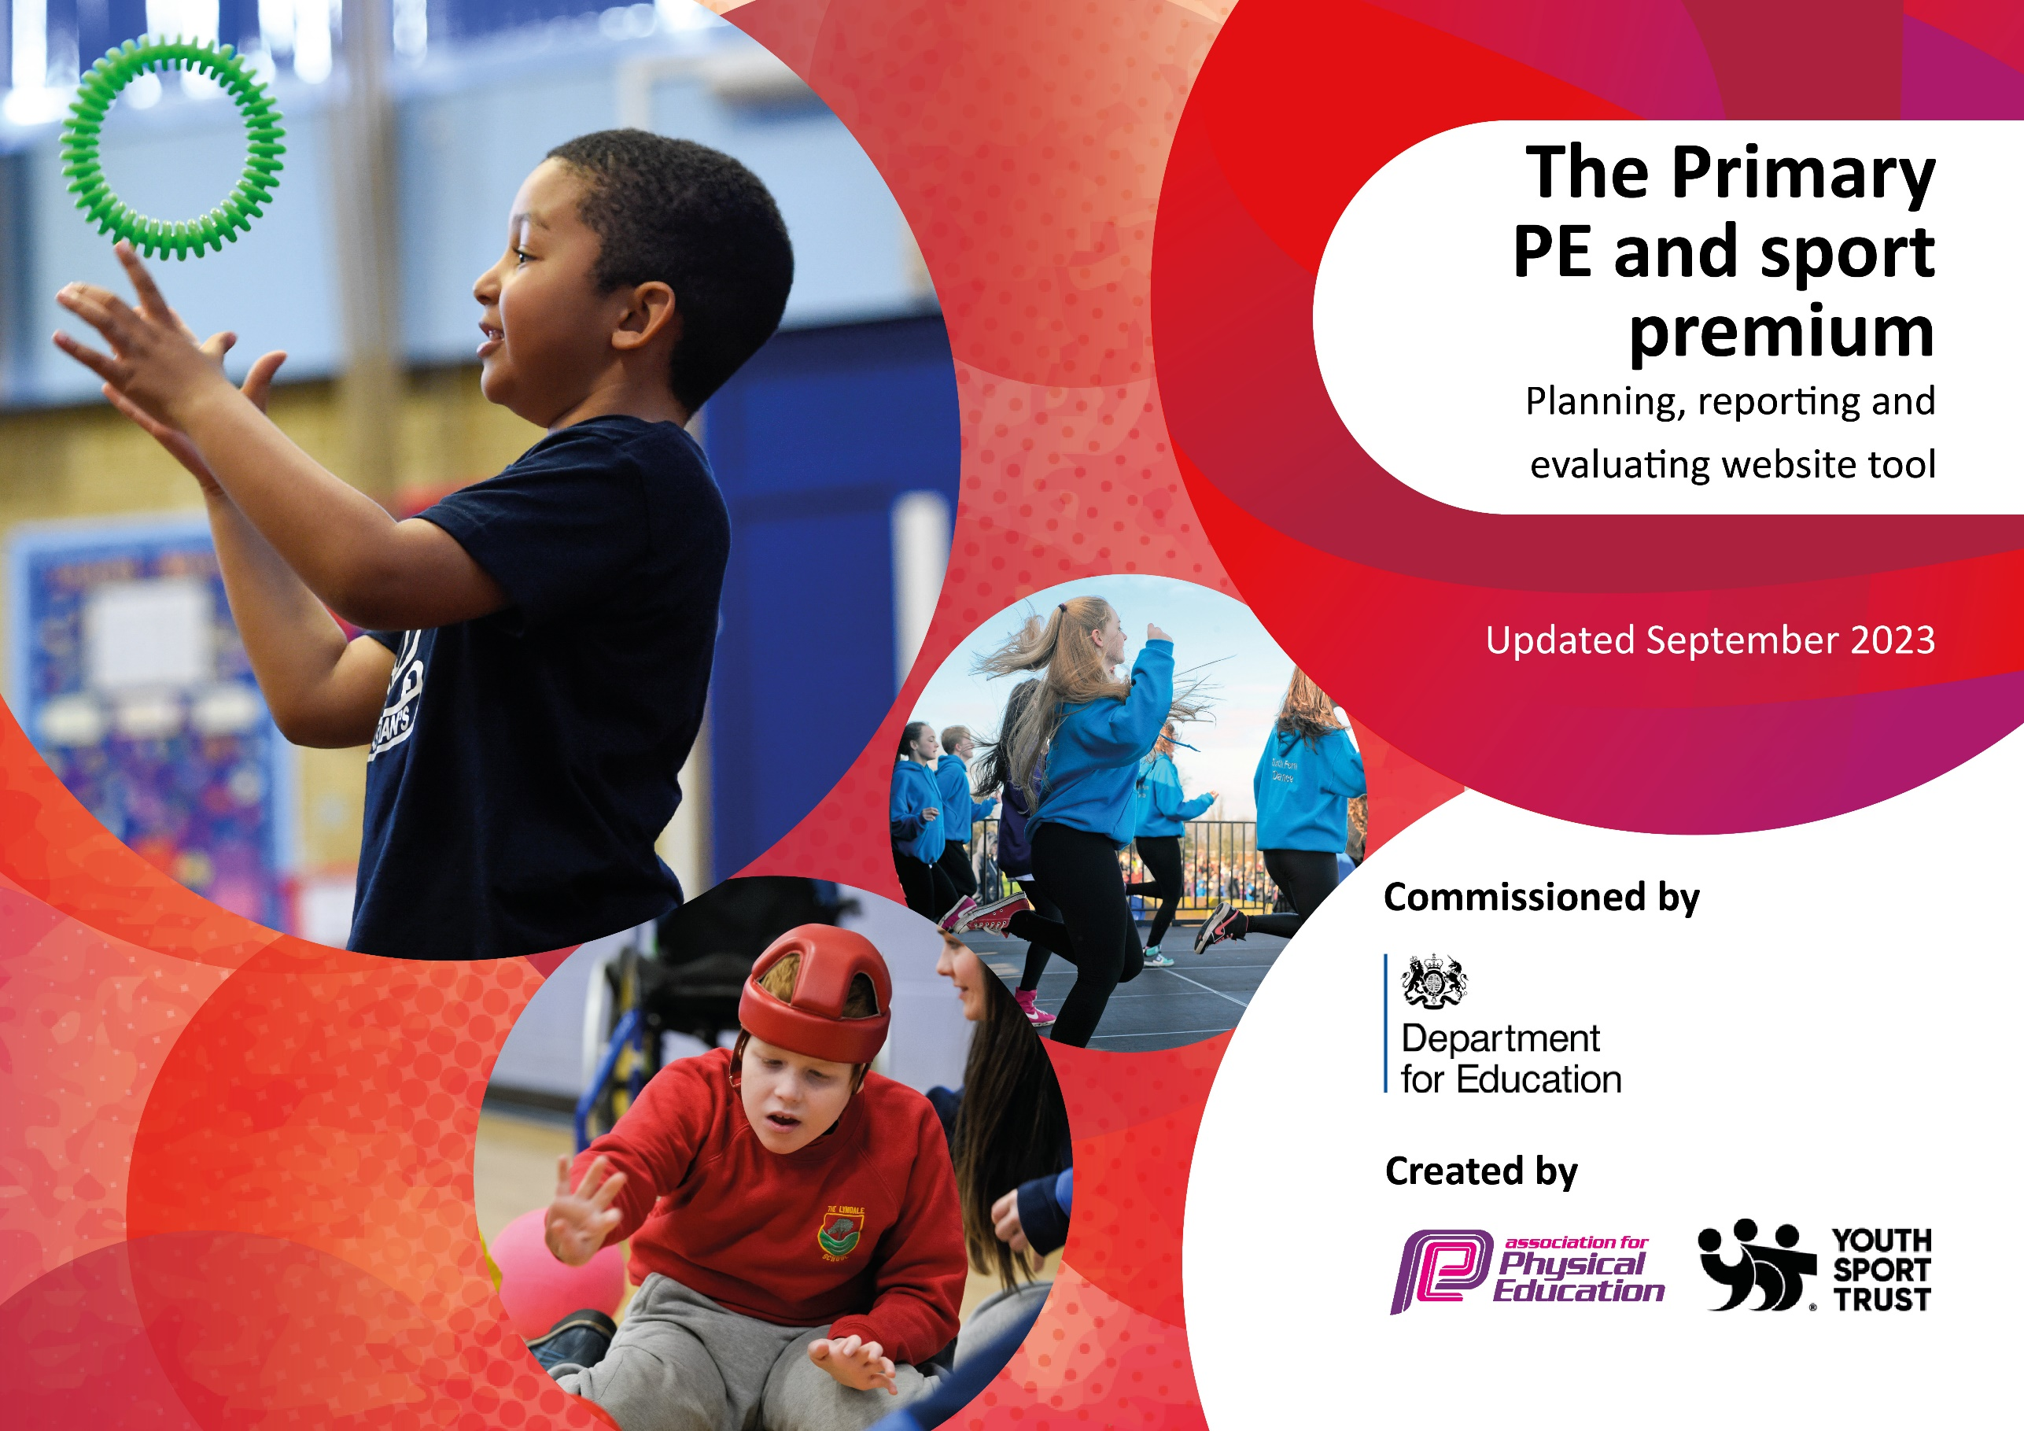

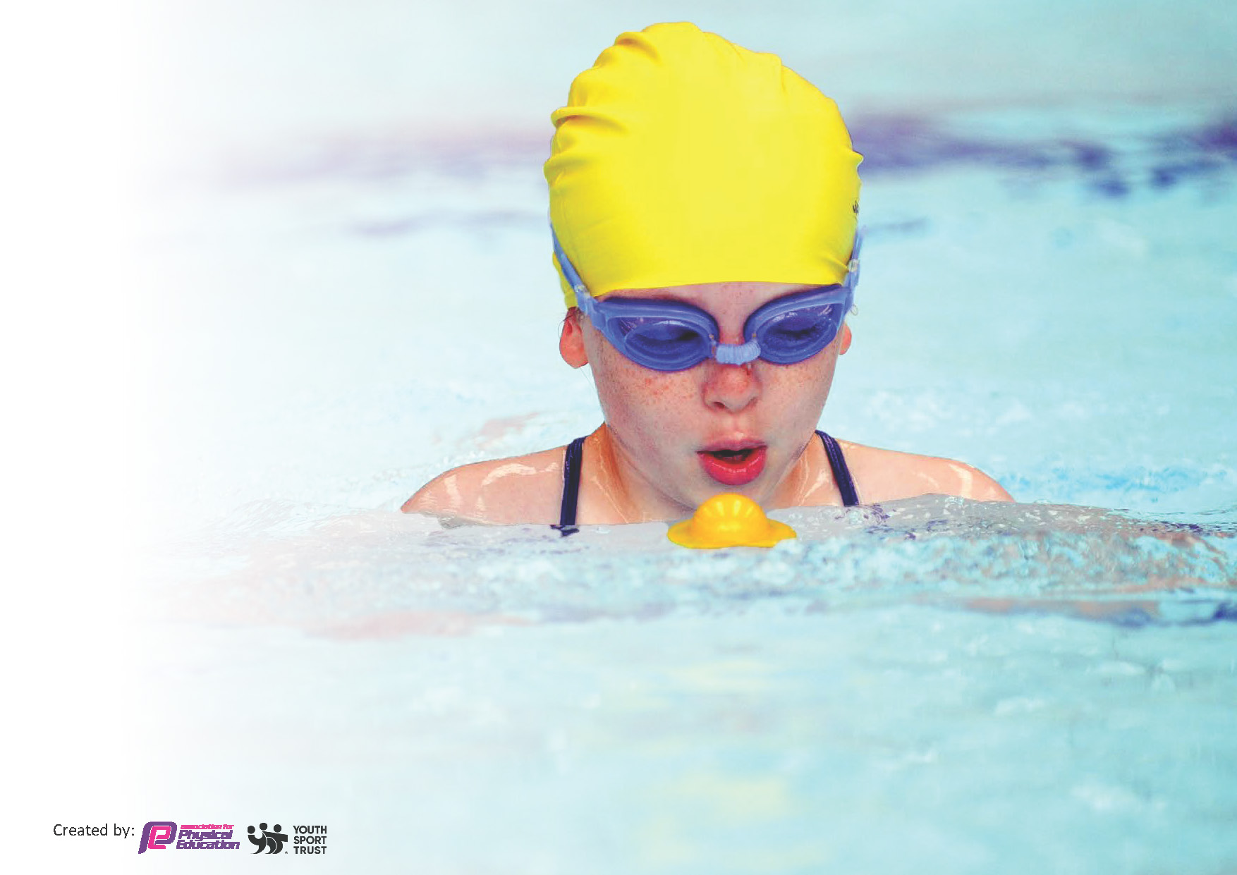
This template can be used for multiple purposes:
by:
- It enables schools to effectively plan their use of the Primary PE and sport premium
- It helps schools to meet the requirements (as set out in guidance) to publish information on their Primary PE and sport premium
- It will be an effective document to support Ofsted inspections enabling schools to evidence progress in Physical Education (PE) and evidence swimming attainment, which forms part of the PE National Curriculum. We would recommend schools consider
the Intent, Implementation and Impact of any spend, as examined within the Education Inspection Framework.

It is important that your grant is used effectively and based on school need.

Schools must use the funding to make additional and sustainable
improvements to the quality of the PE, School Sport and Physical Activity (PESSPA)
they offer. This means that you should use the Primary PE and sport premium to:

- Build capacity and capability within the school to ensure that improvements made now will benefit pupils joining the school in future years
- Develop or add to the PESSPA activities that your school already offers.

The Primary PE and sport premium should not be used to fund capital spend projects; the school’s core budget should fund these. Further detail on capital expenditure can be found in the updated Primary PE and sport premium guidance.

The Primary PE and sport premium guidance, outlines 5 key priorities that funding should be used towards. It is not

necessary that spending has to meet all the key priorities, you should select the priorities that you aim to use any funding towards.

Although completing this template is not a requirement for schools, schools are required to publish details of how they spend this funding. Schools must also outline what the impact this funding has had on pupils’ PE and sport participation and attainment and how any spending will be sustainable in the future. All funding must be spent by 31st July 2024.

The Department for Education has worked closely with the Association for Physical Education (afPE) and the Youth Sport Trust (YST) to develop this template and encourages schools to use it. This template is an effective way of meeting the reporting requirements of the Primary PE and sport premium.
Review of last year’s spend and key achievements (2024/2025)

We recommend you start by reflecting on the impact of current provision and reviewing your previous spend.

Activity/Action | Impact | Comments
Premier coach to support PE lessons and offer CPD throughout the year.  Offering after school clubs to enhance pupils’ opportunities.  Typeform use to promote clubs and trips  MKSSP subscription | Increase of number of pupils attending after school clubs  Increase of opportunities available to pupils.  Staff gaining onsite CPD through team teaching  Greater parent response via typeform than with paper forms. More children signed up for clubs- waiting lists for some.  Was able to attend a few fixtures so children had wider opportunities relating to sport. | Seen an increase of children requesting different sporting afterschool clubs.  Year groups from Year 1 -6 having afterschool sporting provisions available  Simple and easy tool which is easy to use for a majority of parental responses.  Achieved Gold award for school sports which is an achievement helped along by MKSSP

Key priorities and Planning
This planning template will allow schools to accurately plan their spending.

Action – what are you planning to do | Who does this action impact? | Key indicator to meet | Impacts and how sustainability will be achieved? | Cost linked to the action
Use funding for transport to and from events and fixtures.  Raise the number of children able to swim 25m to meet national curriculum requirements | Staff, pupils and parents  Pupils- they will become more water confident and potentially reach national curriculum requirements of swimming 25m  . | Key indicator 4- The pupils have had a wider experience of sports and activities.  Key indicator 5- There has been an increase in the amount of children partaking in events and competitive sports.  Key indicator 4- Broader experience of a range of sports and activities offered to all pupils  Key indicator 2-Engagement of all pupils in regular physical exercise. | More pupils encouraged to try new sports and have opportunities to feel as part of a team. More pupils being active after school.  After initial core swimming assessments showed a low percentage of keystage 2 children had met the national curriculum requirements, the use of a pop-up-pool was invested in. The hope that the percentage of KS2 children who meet the requirements would increase from 25% | £68.00 Taxi to and from events  £5943.11 Pool, lifeguard and swim instructor hire

Premier sports coach to deliver lessons alongside class teacher.  Replace and invest in PE equipment that is required to allow secure teaching of structured PE and sports days  Medals for all children competing in events.  Subscription to MKSSP  Subscription to Typeform  Universal services indoor equipment repair  CPD for teachers by assisting on residential trip to IOW  Supply cover to be booked when class teacher is on residential. | Staff as onsite CPD of all sporting activities covered throughout the year.  Pupils- quality first teaching delivered by trained professionals alongside class teacher and TA’s.  Staff- all resources will be readily available and of good quality to allow quality-first teaching.  Pupils- having the correct equipment to partake in planned lessons  Pupils have a variety of resources for sports day events  Children- being recognized for their participation in different sporting achievements  Pupils- access to events hosted throughout the year.  Inclusion for SEND children with Kommando kids  Staff CPD offered and support for staff.  Staff- quick and easy to utilize questionnaires and to sort responses  Parents- easy access to sign up for clubs, trips and events  All children to have wider opportunities for PE with repaired benches for balancing replacement of PE mats.  Children as they will be able to engage with new members of staff who they wouldn’t usually cross paths with.  Staff will gain a clearer understand of some of the children in UKS2 who they may have the opportunity to teach at a later date.  Children will have stability of one adult (supply) for the duration of the week. | Key indicator 1- Increased confidence, knowledge and skills of all staff in teaching PE and sport.  Key indicator 3-The profile of PE and sport is raised across the school as a tool for whole school improvement.  Key indicator 3-The profile of PE and sport is raised across the school as a tool for whole school improvement.  Key indicator 4- Broader experience of a range of sports and activities offered to all pupils  Key indicator 3-The profile of PE and sport is raised across the school as a tool for whole school improvement.  Key indicator 4- Broader experience of a range of sports and activities offered to all pupils  Key indicator 5- Increased participation in competitive sport  Key indicator 1- Increased confidence, knowledge and skills of all staff in teaching PE and sport  Key indicator 3- The profile of PE and sport is raised across the school as a tool for whole school improvement  Key indicator 3- The profile of PE and sport is raised across the school as a tool for whole school improvement.  Key indicator 4- . Broader experience of a range of sports and activities offered to all pupils.  Key indicator 5- Increased participation in competitive sport.  Key indicator 2- Engagement of all pupils in regular physical activity  Key indicator 3-The profile of PE and sport is raised across the school as a tool for whole school improvement.  Coverage for CPD of individual teachers. | Primary teachers more confident to deliver effective PE supporting pupils to undertake extra activities inside and outside of school.  Pupils will have the correct resources to play competitive sports after lessons have been delivered. This allows up to enter more events hosted by MKSSP and become familiar with rules through different types of games.  Children to be celebrated in assembly for their achievement. Medal to have insert made for the sport they participated in.  More children showing an interest in attending events on a competitive level.  Falconhurst is becoming recognized as a school which is participating in more events.  Easy access for parents to engage and sign up for clubs and trips for their child  Simple to use for staff and multiple questionnaires are available  More environmentally friendly as online so no paper needed.  Safer environment for the children, increased activity available during Gym sessions  All teachers given the opportunity to request to attend the residential. Teachers selected by SLT in regards to relevance of going (e.g. moving year group) Teacher to broaden their knowledge and understanding of factors to consider with on residentials.  Children had stability and accessed the curriculum, which was planned by the class teacher whilst they were away completing CPD – gaining residential knowledge. | £7030 for 8 teachers to undertake CPD through explicit teaching alongside coach.  Sports directory order £825.17  Registration fee for Football league for 3/4 and 5/6 £150  £49.23 Amazon order for medals  £1150.00 Membership to MKSSP  £140.00  £516.13  £1653.39  £1075.00  Total spend for academic year 2024-2025  £18600.00

Key achievements 2023-2024
This template will be completed at the end of the academic year and will showcase the key achievements schools have made with their Primary PE and sport premium spending.

Activity/Action | Impact | Comments
Subscription to MKSSP  Participated in a wider range of events where transport has been an issue previously.  New equipment order including medals  Hire of pop-up-pool, lifeguard and swim instructor  Premier sports coach to support CPD and deliver quality first lessons | More children have accessed events across key-stages meaning more children have been given the opportunity to partake in events which they would normally miss out on.  Allowing us to host inter-school fixtures as well as deliver high level PE lessons (football, netball and badminton) as we now have equipment which is of a high standard.  Allows pupils to become familiar with rules and structure of games before competing in competitive matches  Pupils are celebrated in assembly for participation in events held by MKSSP  A higher percentage of children are meeting the national curriculum requirements of swimming 25m at the end of KS2. Percentage of children who can self-rescue and are water confident also increased.  25m went from 29%to 51%  Self-rescue increasing from 33% to 86%  Water confidence again increasing from 35% to 82%.  Lessons were also offered to Lower KS2 and year 2, allowing for progress to be seen throughout their time at Falconhurst into year 6.  Specialized provision for children on SEND register as they had access to the pool alongside their 1:1.  More teachers are now more confident with delivering a range of sporting lessons and are able to draw in skills and strategies witnessed during team-teaching with sports coach, | Positive comments from both adults and pupils regarding them being able to attend fixtures and events. Be noticed by other schools as a potential competitive at such events.  Positive impact on pupils PE lessons and break time play. Children enjoy being celebrated. Medals are adapted for each individual sport with different insert being designed by EY.  Very positive impact on all children, parents were supportive and thankful for giving children this opportunity.  An increase in the number of staff offering after school clubs which are of a sporting nature, pupils are more confident with their class teacher being present during lessons.  With the support of premier coach children attainment has increased throughout the year in all year groups.  All assessment is carried out by coach alongside class teacher.

Swimming Data
Meeting National Curriculum requirements for swimming and water safety.
Priority should always be given to ensuring that pupils can perform safe self-rescue even if they do not fully meet the first two requirements of the National Curriculum programme of study

Question | Stats: | Further context  Relative to local challenges
What percentage of your current Year 6 cohort can swim competently, confidently and proficiently over a distance of at least 25 metres? | Started at 29%  51% | 29% - we are struggling to get pool space due to our local pool having limited availability and when classes were available they were considerably larger (30 children per class for 30 minutes). We have to limit the number of pupils attending swimming lessons during one term which means some pupils have attended fewer swimming lessons than others. The use of the pop-up-pool allowed for an increased number of children, across the year groups, to participate in swimming lessons. These lessons were in a shorter block (3 week swimming every other day for 30 minutes with the possibility of top-up lessons for those almost there and specialized SEND provision alongside 1:1 children) giving them more water time and smaller classes than were offered at the local pool.  Only 5 out of 45 year 6 pupils are still unable to swim any distance unaided –their water confidence has grown through this provision.
What percentage of your current Year 6 cohort can use a range of strokes effectively (for example, front crawl, backstroke, and breaststroke)? | 51% | 51% are now able to swim using front crawl and back stroke confidently in year 6

What percentage of your current Year 6 cohort are able to perform safe self-rescue in different water-based situations? | 86% | Started off at 55% and increased to 86% after extra sessions using pop-up-pool
If your schools swimming data is below national expectation, you can choose to use the Primary PE and sport premium to provide additional top-up sessions for those pupils that did not meet National Curriculum  requirements after the completion of core lessons. Have you done this? | Yes | Percentage of children able to swim 25m has increased from 29% to 51%  Water confidence has increased from 53% to 78%
Have you provided CPD to improve the knowledge and confidence of staff to be able to teach swimming and water safety? | Not yet, we are looking into training PE lead with Swimming teacher training level 1 and 2

Signed off by:

Head Teacher: | Louise Aird
Subject Leader or the individual responsible for the Primary PE and sport premium: | Emma Young
Governor: | (Name and Role)
Date:

